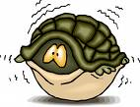
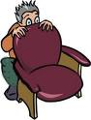
Let’s talk about FEARS

Conversation cards
What are you afraid of?
Are you afraid of going to the dentist or the doctor?
Why or why not?
What’s your biggest fear in life? Are you afraid that it might come true?
What were you afraid of when you were a child?
Are you afraid of ghosts or monsters?
Why or why not?
Do you ever have nightmares (bad dreams)?
What are they about?
What animals do you think are scary?
Why?
What’s the most frightening experience you’ve ever had?
How do you react when you see something frightening?
What can you do to overcome your fears?
Were you afraid of the dark as a child?
Do you like horror movies?
Do you think young children should be allowed to watch horror movies?
Some people are terrified of speaking in public.
Are you?
Are you afraid of getting old?
Why or why not?
Have you ever seen a TV show where people face their fears for money? (e.g. Fear Factor)
Would you do this?
Are you afraid of dying?
Explain why or why not.
Are you afraid of being ill?
What diseases are you most afraid of?
What kind of things make you nervous?

1
2
3
4
Proverbs & quotes
‘Fear makes the wolf bigger than he is.’

‘A good scare is worth more to a man than good advice.’
‘Why are we scared to die? Do any of us remember being scared when we were born?’

Discuss. Do you agree?
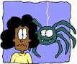

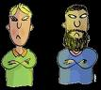

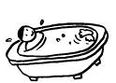
5


Match
 | acrophobia | a | fear of being trapped in a small space
 | aerophobia | b | fear of flying
 | agoraphobia | c | fear of heights
 | arachnophobia | d | fear of open spaces and public places
 | claustrophobia | e | fear of spiders
 | hydrophobia | f | fear of strangers or foreigners
 | xenophobia | g | fear of water

6

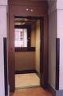
7

